Nick Amundsen

W01323151

M/CS 335

**Lab 2**

**Results:**

Part B with old points labeled, and each plane labeled for Xj = 0.

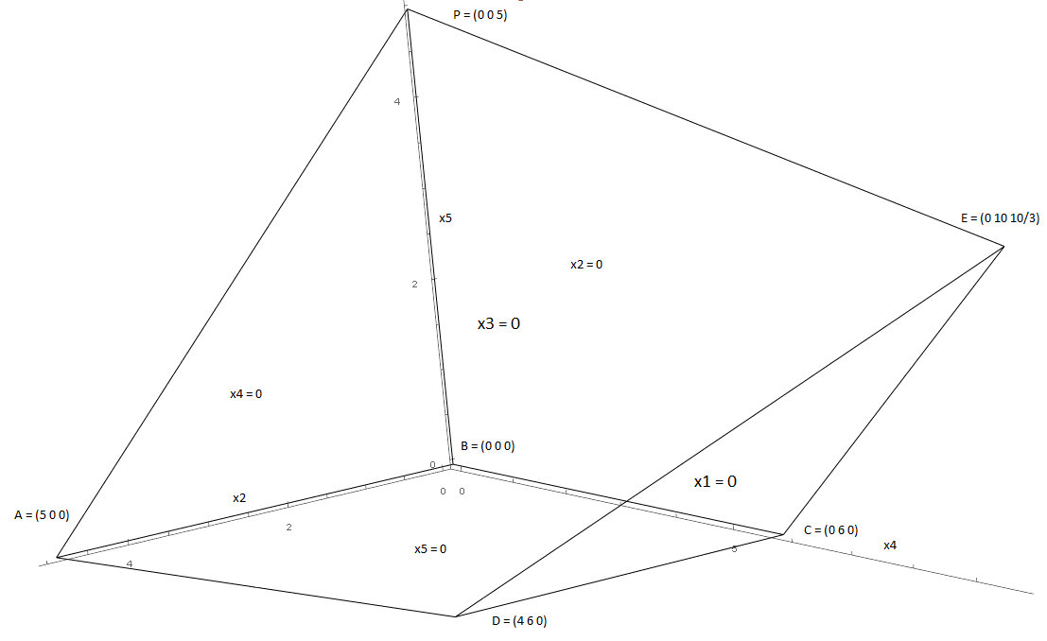

|  |  |  |  |  |  |
| --- | --- | --- | --- | --- | --- |
| A | B | C | D | E | P |
| (5 0 0) | (0 0 0) | (0 6 0) | (4 6 0) | (0 10 10/3) | (0 0 5) |

Part D with corner points labeled with exact values, and each plane labeled for Xj = 0.

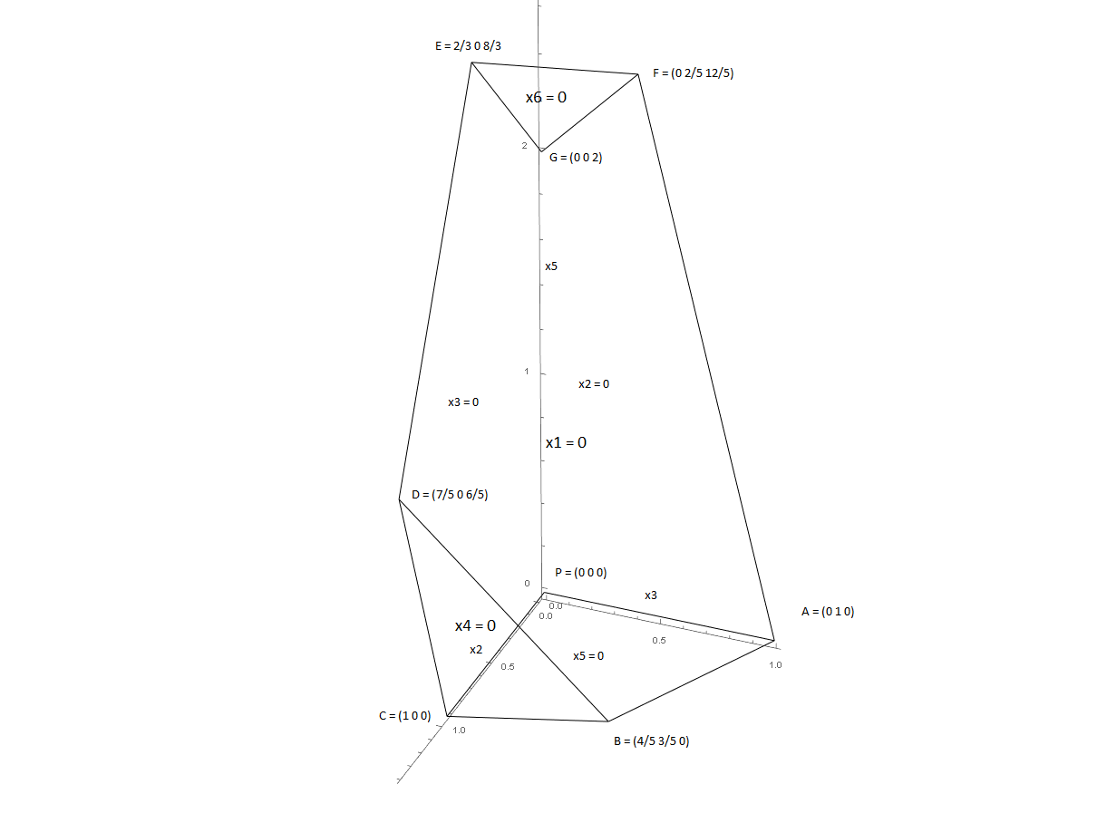

|  |  |  |  |  |  |  |  |
| --- | --- | --- | --- | --- | --- | --- | --- |
| A | B | C | D | E | F | G | P |
| (0 1 0) | (4/5 3/5 0) | (1 0 0) | (7/5 0 6/5) | 2/3 0 8/3 | 0 2/5 12/5 | (0 0 2) | (0 0 0) |

**Mathematica input/output:**

**Part B:**

**Input:**

p1 = Plot3D[{(5/6) x4 + 0 x2 - 5}, {x2, 0, 18}, {x4, 0, 20}];

p2 = Plot3D[{-x2 - (1/6) x4 + 5}, {x2, 0, 18}, {x4, 0, 20}];

Show[p1, p2, PlotRange -> {0, 10}]

Solve[{5 - ((5/6) x4 - x5) == 0, 5 - (x2 + (1/6) x4 + x5) == 0,

x2 == 0}, {x2, x4, x5}];

Solve[{5 - (x2 + (1/6) x4 + x5) == 0, x4 == 0, x5 == 0}, {x2, x4, x5}];

Solve[{5 - (x2 + (1/6) x4 + x5) == 0, x4 == 0, x2 == 0}, {x2, x4, x5}];

Solve[{5 - ((5/6) x4 - x5) == 0, x2 == 0, x5 == 0}, {x2, x4, x5}];

Solve[{5 - ((5/6) x4 - x5) == 0, 5 - (x2 + (1/6) x4 + x5) == 0,

x5 == 0}, {x2, x4, x5}];

e1 = Graphics3D[Line[{{0, 0, 0}, {5, 0, 0}}]];

e2 = Graphics3D[Line[{{0, 0, 0}, {0, 6, 0}}]];

e3 = Graphics3D[Line[{{5, 0, 0}, {4, 6, 0}}]];

e4 = Graphics3D[Line[{{0, 6, 0}, {4, 6, 0}}]];

e5 = Graphics3D[Line[{{0, 0, 0}, {0, 0, 5}}]];

e6 = Graphics3D[Line[{{0, 10, (10/3)}, {0, 0, 5}}]];

e7 = Graphics3D[Line[{{0, 6, 0}, {0, 10, (10/3)}}]];

e8 = Graphics3D[Line[{{5, 0, 0}, {0, 0, 5}}]];

e9 = Graphics3D[Line[{{4, 6, 0}, {0, 10, (10/3)}}]];

Show[e1, e2, e3, e4, e5, e6, e7, e8, e9, Boxed -> False,

Axes -> True, AxesEdge -> {{-1, 1, -1}, {0, 0}, {0, 0}},

AxesLabel -> {x2, x4, x5}, ViewPoint -> {5, 2, 3}]

**Output:**

Plot for part B as well as corner point values.

{{x2 -> 0, x4 -> 10, x5 -> 10/3}}, {{x2 -> 5, x4 -> 0, x5 -> 0}}, {{x2 -> 0, x4 -> 0, x5 -> 5}},

{{x2 -> 0, x4 -> 6, x5 -> 0}}, {{x2 -> 4, x4 -> 6, x5 -> 0}}

**Part D:**

**Input:**

p1 = Plot3D[{-2 x2 - 4 x3 + 4}, {x2, 0, 6}, {x3, 0, 6}];

p2 = Plot3D[{3 x2 + x3 - 3}, {x2, 0, 6}, {x3, 0, 6}];

p3 = Plot3D[{x2 + x3 + 2}, {x2, 0, 6}, {x3, 0, 6}];

Show[p1, p2, p3, PlotRange -> {0, 10}, AxesLabel -> {x2, x3, x5}]

Solve[{4 - (2 x2 + 4 x3 + x5) == 0, 3 - (3 x2 + x3 - x5) == 0,

x5 == 0}, {x2, x3, x5}];

Solve[{4 - (2 x2 + 4 x3 + x5) == 0, x2 == 0, x5 == 0}, {x2, x3, x5}];

Solve[{3 - (3 x2 + x3 - x5) == 0, x3 == 0, x5 == 0}, {x2, x3, x5}];

Solve[{4 - (2 x2 + 4 x3 + x5) == 0, 2 - (-x2 - x3 + x5) == 0,

x2 == 0}, {x2, x3, x5}];

Solve[{4 - (2 x2 + 4 x3 + x5) == 0, 3 - (3 x2 + x3 - x5) == 0,

x3 == 0}, {x2, x3, x5}];

Solve[{2 - (-x2 - x3 + x5) == 0, x2 == 0, x3 == 0}, {x2, x3, x5}];

Solve[{4 - (2 x2 + 4 x3 + x5) == 0, 2 - (-x2 - x3 + x5) == 0,

x3 == 0}, {x2, x3, x5}];

e1 = Graphics3D[Line[{{0, 0, 0}, {1, 0, 0}}]];

e2 = Graphics3D[Line[{{0, 0, 0}, {0, 1, 0}}]];

e3 = Graphics3D[Line[{{1, 0, 0}, {4/5, 3/5, 0}}]];

e4 = Graphics3D[Line[{{0, 1, 0}, {4/5, 3/5, 0}}]];

e5 = Graphics3D[Line[{{0, 1, 0}, {0, 2/5, 12/5}}]];

e6 = Graphics3D[Line[{{1, 0, 0}, {7/5, 0, 6/5}}]];

e7 = Graphics3D[Line[{{0, 2/5, 12/5}, {0, 0, 2}}]];

e8 = Graphics3D[Line[{{7/5, 0, 6/5}, {2/3, 0, 8/3}}]];

e9 = Graphics3D[Line[{{2/3, 0, 8/3}, {0, 0, 2}}]];

e10 = Graphics3D[Line[{{2/3, 0, 8/3}, {0, 2/5, 12/5}}]];

e11 = Graphics3D[Line[{{7/5, 0, 6/5}, {4/5, 3/5, 0}}]];

Show[e1, e2, e3, e4, e5, e6, e7, e8, e9, e10, e11, Boxed -> False,

Axes -> True, AxesEdge -> {{-1, 1, -1}, {0, 0}, {0, 0}},

AxesLabel -> {x2, x3, x5}, ViewPoint -> {5, 2, 3}]

**Output:**

Plot for part D as well as corner point values.

{{x2 -> 4/5, x3 -> 3/5, x5 -> 0}}, {{x2 -> 0, x3 -> 1, x5 -> 0}}, {{x2 -> 1, x3 -> 0, x5 -> 0}},

{{x2 -> 0, x3 -> 2/5, x5 -> 12/5}}, {{x2 -> 7/5, x3 -> 0, x5 -> 6/5}}, {{x2 -> 0, x3 -> 0, x5 -> 2}},

{{x2 -> 2/3, x3 -> 0, x5 -> 8/3}}